COSHH ASSESSMENT NCS/FM/070 Issue005/Jul09

Ref: COSHH 04

Assessed by: Matt Traynor Position: Managing Director

Date: January 2022

Reviewed by: Matt Traynor
Position: Managing Director
Date: January 22
Issue: 008/Jan 22

Trade name / Supplier: Telephone number:

Contact:

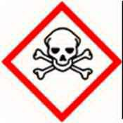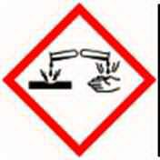Toxic Corrosive

Product type:

Grease

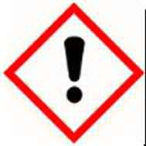Irritant

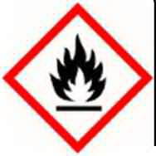Highly
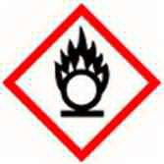Flammable

Chemicals and appearances:

Thick, viscous pale yellow / brown semi solid

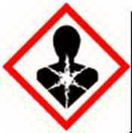Harmful
Oxidising

Risk associated with use: | Prolonged skin contact can lead to dermatitis and skin cancer. Irritating to skin, eyes and respiratory system
Personal Protection: | Wear overalls and rubber gloves. Do not eat, drink or smoke when using
Storage: | Store and use from containers designed for use with this product.  Keep containers closed when not in use.  Store and dispense in well ventilated areas - away from heat and sources of ignition
Disposal: | Return any unused product to supplier, or plant depot.  Any material contaminated by the product should be designated as special waste, and disposed of through a specialist waste disposal contractor
Fire: | Powder, foam halon or Carbon Dioxide extinguishers must be available at storage areas  DO NOT USE WATER  Empty containers represent a fire hazard, do not accumulate, return to supplier
Spillage: | Confine and absorb with inert material e.g. sand.  Collect any leaking liquid in containers and clean with detergent. Wear gloves

Appointment Effect First Aid

Dermatitis, possible skin cancer
Skin
Wash well with plenty of soap and water.
Remove contaminated clothing. Seek medical advice if irritation persisits

Irritation, stinging Flush eyes with copious quantity of water.
Eyes
If irritation persists, seek medical advice

Inhalation Irritation to nose and throat Move to fresh air and rest. If symptoms persist seek medical advice

Irritation, nausea DO NOT INDUCE VOMITING.
Swallowing
Wash mouth out with water and seek medical advice

